OLS Regression on wineRed to see which p values are significant:

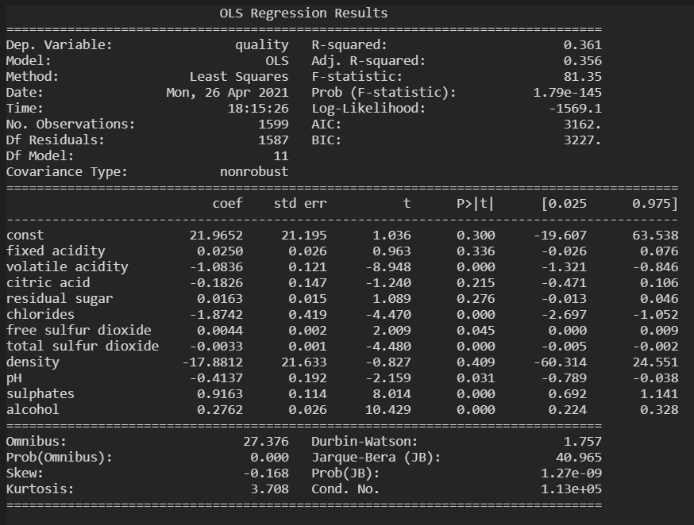



Logistic Regression on wineRed to see which p values are significant:

